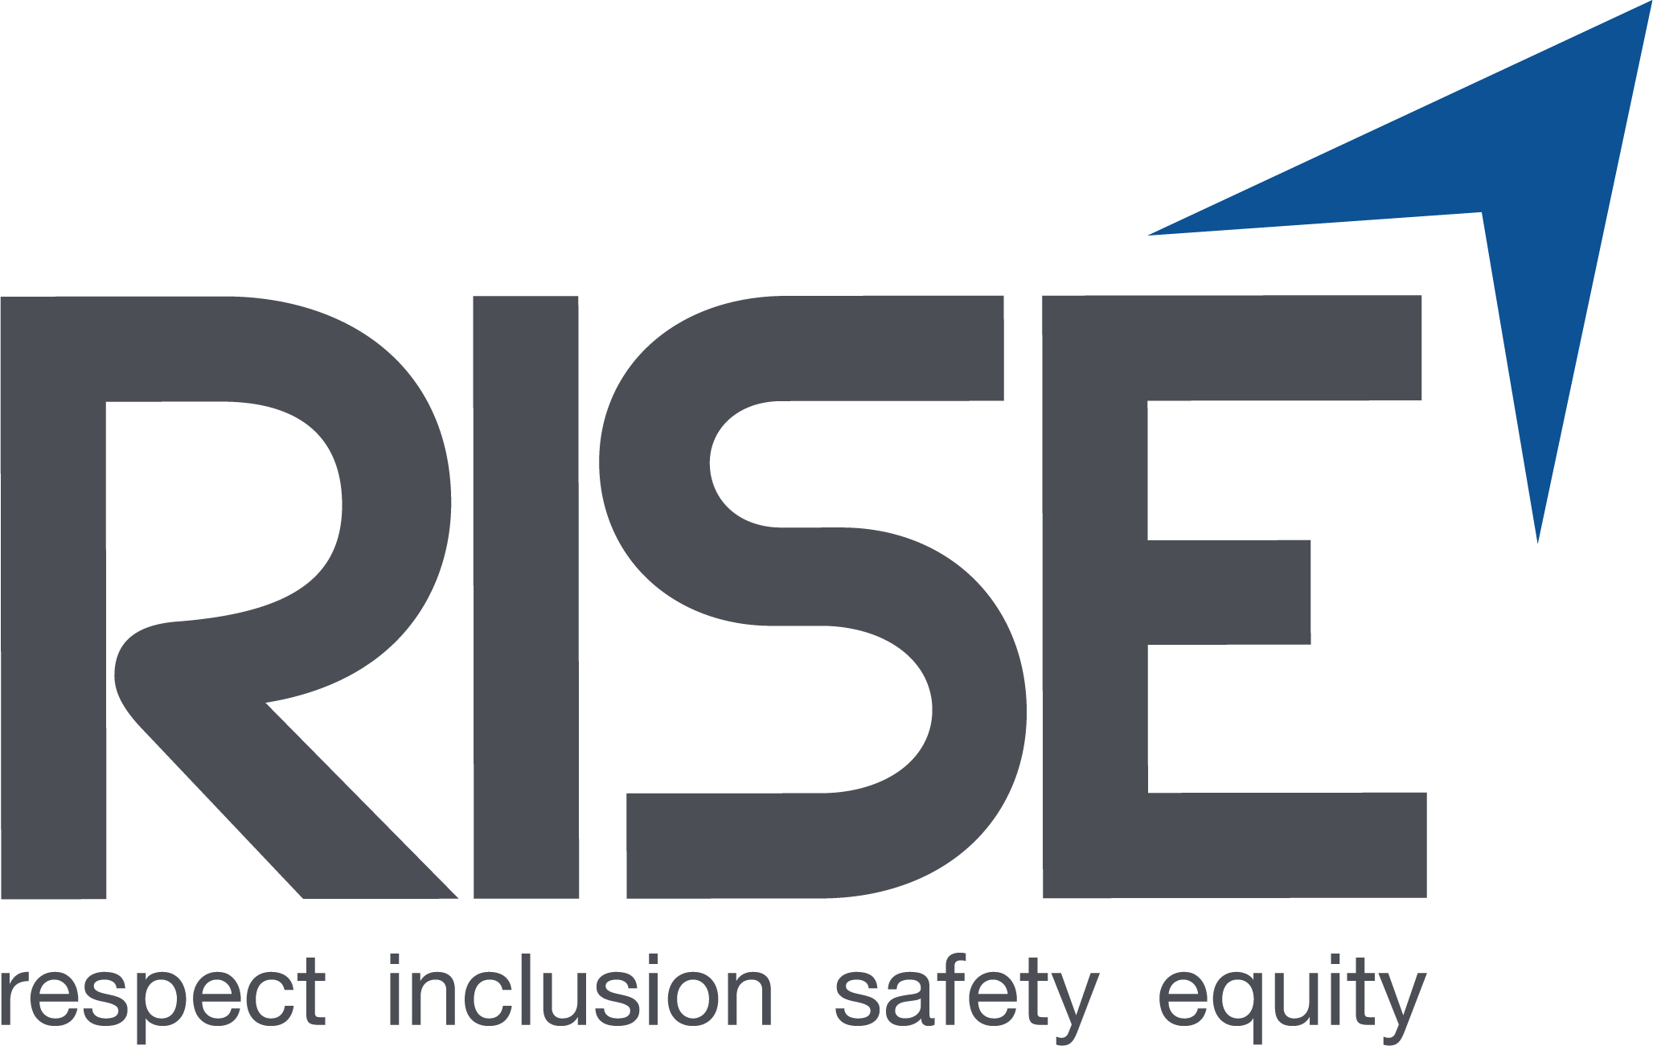

Thank you for your participation in the RISE Up evaluation of construction job site culture.

1. Please rate your current knowledge about… | Very strong | Somewhat strong | Somewhat weak | Very weak
The expectations for acceptable behavior towards other workers on this job site.
How to communicate respectfully with people of a different age, race/ethnicity, gender, and/or sexuality than you.
Your employer’s policies and procedures regarding discrimination and harassment.
What to do if you experience discrimination or harassment on this job site.
What to do if you hear about or observe someone else experience discrimination or harassment on this job site.

2. How much do you agree or disagree? | Strongly Agree | Agree | Disagree | Strongly Disagree
Supervisors on this jobsite address discrimination and harassment when they see it or hear about it.
There are consequences for workers who engage in discrimination or harassment on this jobsite.
Race-based discrimination and harassment are a problem on this jobsite.
Gender-based discrimination and harassment are a problem on this jobsite.

3. On this job site, state how many times you have... | 0 times | 1-2  times | 3-5 times | 6-9 times | 10+  times
Seen others experience any discrimination, harassment, bullying, or hazing.
Heard offensive stereotypes or slurs that were based on race, gender and/or sexuality (not directed towards you).
Heard offensive language that was based on race and/or gender (not directed towards you)
Seen others be called names, be cursed at, or be unnecessarily yelled at.
Seen others be asked about their gender or gender identity.

Seen others be unfairly denied opportunities to learn new skills.

Seen others be unfairly assigned to “grunt” work not related to learning the skills of their trade (like cleaning).
Seen others be isolated or ignored at work.

Seen others unfairly assigned fewer work hours than other workers.

6. Please briefly describe any discrimination or harassment you’ve seen or heard on this job site:

Finally, we would like to collect some demographic information.

7. What is your position on this job site?
- Apprentice
- Journey worker
- Other tradesperson
- Supervisor/foreperson/superintendent/project manager
- Other (please specify): ___________________________________

8. (Optional) What trade do you work in?
Please specify ______________________________

9. Is your employer…

- The prime contractor on this job site
- A subcontractor on this job site

10. How many months have you been working on this job site? _______

11. What is the zip code of your home address? _________

12. What is your age? _______

13. What is your race/ethnicity?
(Please check all that apply)
- White
- Black or African American
- Asian or Asian American
- American Indian or Alaska Native
- Native Hawaiian or other Pacific Islander
- Latino/a, Hispanic, Spanish
- Another race/ethnicity, please specify: ___________________________________

14. What is your gender identity?
- Male
- Female
- Non-binary

15. What is your sexual identity?
- Heterosexual or straight
- Sexual minority (such as gay, lesbian, bisexual, queer, pansexual, or asexual)

