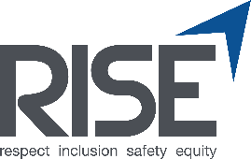 Training Evaluation Form

Date:

Title and Location of Training:

Trainer:

Instructions: Please indicate your level of agreement with the statements listed below in #1 – 8.

 | Strongly Agree | Agree | Neutral | Disagree | Strongly Disagree
The objectives of the training were clearly defined.
Participation and interaction is encouraged.
The topics covered were relevant.
This training will be useful in my professional life.
The trainer was knowledgeable about the topic.
Do you feel you better understand Sound Transit expectations on Respectful Worksites?
After this training, do you feel better equipped to support your team in fostering an inclusive, respectful worksite?

What did you like most about this training?

How can the training be improved?

Do you have any other feedback about this training?

